Menu

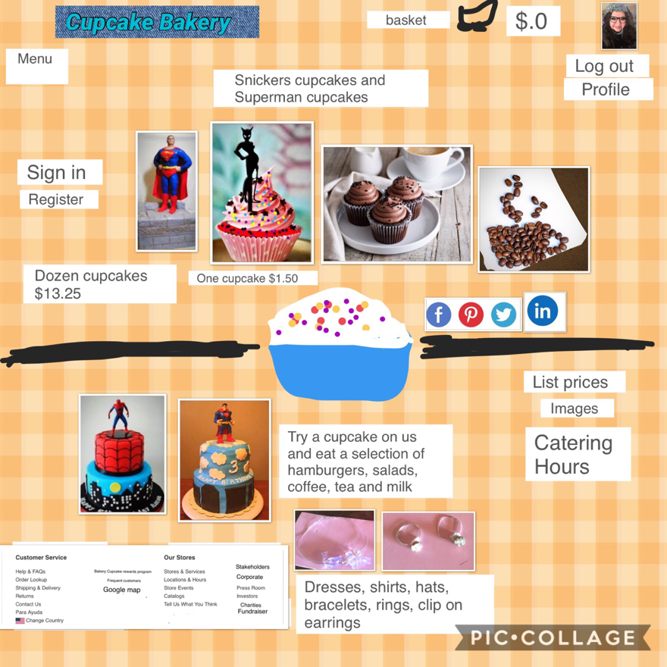

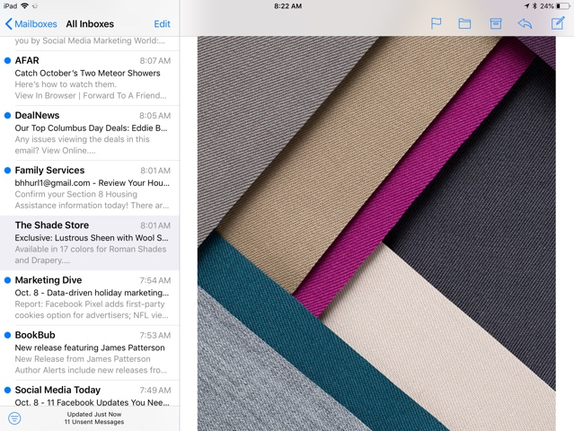Shades for BACKGROUND

# Project Angular PHP

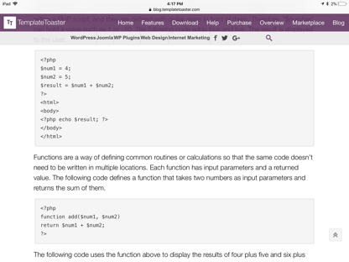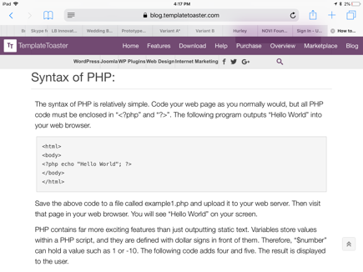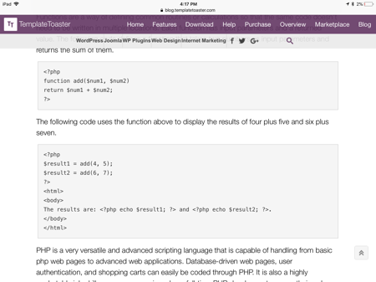

This is is a project to make, bake and sell affordable cupcakes by one or a dozen, yet quality, design and

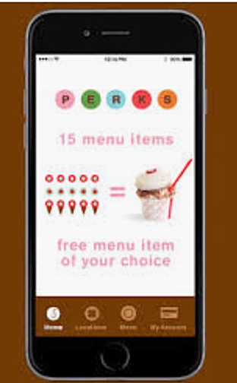

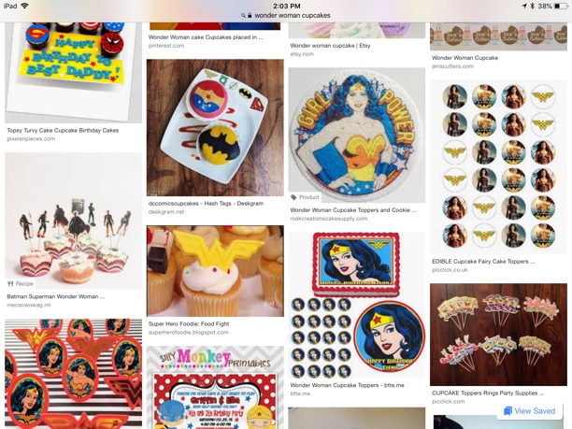 ingredients are customer wishes on any day. This is Cupcake Bakery. <head><title><subtitle>separated by paragraphs to left side of page. <text> a web application, Google search website “Cupcake Bakery” business offering catering, location, delivery, pickup, takeout, charities, fundraising, home page 14 pages long, mobile, app for App Store IOS, iPhone, iPad, and laptop. Flour, powder sugar, frosting, fondue, rice crispy, icing, sprinkles and candy such as, snickers, peanut butter cups, chocolate, tweenkies, Hershey’s and superheroes such as, Superman, Wonder Woman, Batman, and Spider-Man. Commerce and Shopify to sell with other items such as, bracelets, rings and necklaces and clip earrings, dresses, shirts and caps.

# Cupcake Bakery

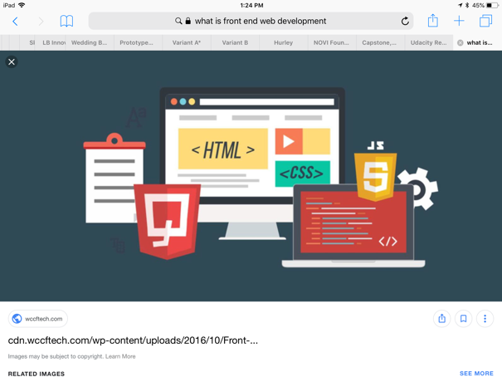

The prices, each cupcake $1.50 for a dozen $13.25 customer receives coffee, tea, milk, Pepsi, and in hot and cold drinks with cream milk and sugar, stirs, and packets. Also, hamburger, couscous chicken garbanzo salad with lettuce and spinach and dressings of three kinds. Hamburger is cheese, lettuce, bacon, tomatoes, pickles, condiments, chili, in layers. Onion on side. Tortilla chips. Fabrics patterns cut out and sew, buy quantity in hats and design craft Hobby Lobby or Joanne’s and Michaels. It is clothing with cupcake bakery.

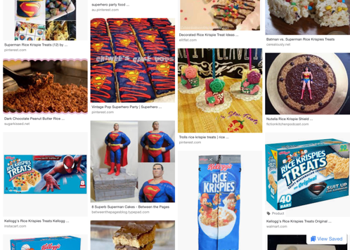

# Candy cupcakes childhood

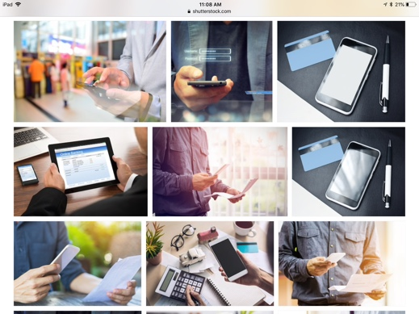

Plain cupcake then insert a butter cream then cover with a frosting top then add snickers, or add peanut butter cup, mini bite size, tweenkies, Hershey’s and sprinkles.

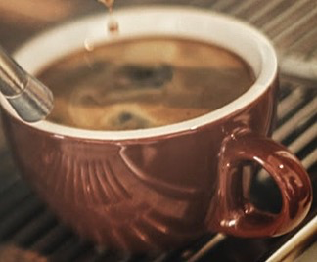

# Superheroes from childhood cupcakes

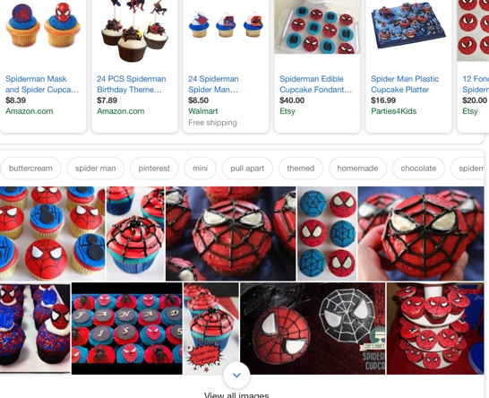

Plain cupcake insert butter cream top frosting add Spider-Man, Wonder Woman, Superman, Cat Woman and add to top frosting made of rice crispy and fondue, color, chocolate strings with cotton candy spray paint food.

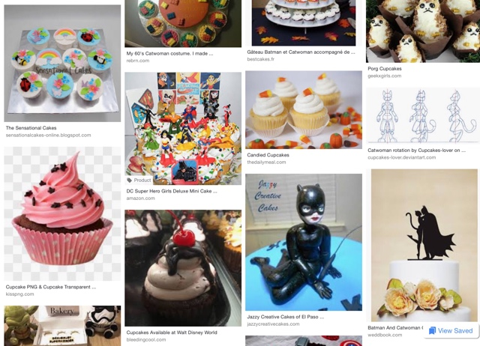Brigida Brigett Hurley, [bhhurl1@gmail.com](mailto:bhhurl1@gmail.com), 480-400-2734, startup cupcake bakery in community of homes, church, shopping, neighborhood.